Year 11 Biology 2a

Task 9

Classification and Ecosystems

Narrogin Senior High School
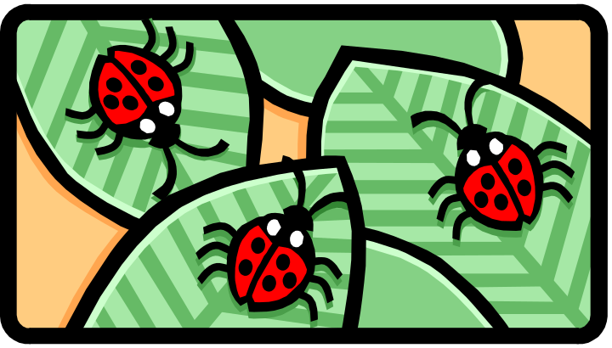

Total: 45 Marks
Section A: Multichoice 20 marks

Scientists describe biodiversity as:
- all of the endangered species from a particular part of the world.
- the variety of life on Earth
- the study of living systems and how diverse they are
- the study of cellular processes and how they vary

Which of the following is Not a reason to preserve biodiversity?
- Organisms may be found that have a medicinal value
- New plants may be found that can contribute to the world’s food supply
- Humans need to prevent natural evolution
- Genetic material may be found that could be used to improve existing crops.

The Baikal seal is a species of earless seal found only in the fresh water of Lake Baikal in Siberia, Russia. The fact that it lives nowhere else means it is an example of:
- a phylogenetic species.
- an endemic species.
- a morphological species.
- an introduced species.

Australian flora and fauna stands apart from the rest of the world because of:
- the uniqueness of the Great Barrier reef.
- its diversity, uniqueness and large number of endemic species.
- its isolation.
- the marsupials, which include dingoes and koalas.

An ecosystem consists of:
- organisms that make their own food.
- all living and non-living things in an area.
- a population of a particular species in a particular area.
- predators and prey.

Which of the following would not be considered an ecosystem?
- A desert
- A eucalypt forest
- A tropical rainforest
- A zoo

The myrtle warbler and Audubon’s warbler were originally considered to be different species. Now these birds are classified as eastern and western forms of the yellow-rumped warbler. The main reason for reclassifying the two species was:

- the myrtle warbler and Audubon’s warbler live in very similar habitats.
- the myrtle warbler and Audubon’s warbler have the same breeding habits, both creating a cup-shaped nest in a conifer.
- their trill-like songs are almost indistinguishable.
- the two forms will interbreed successfully where their habitats overlap.

Which is the correct sequence for the classification of organisms?

- kingdom, class, order, genus, species, family
- kingdom, order, phylum, class, family, genus, species
- kingdom, phylum, order, class, genus, family, species
- kingdom, phylum, class, order, family, genus, species

- The greatest degree of similarity would be seen in organisms which belong to two separate

- classes of a phylum
b) species of a genus
c) families of an order
d) families of a class

- In which one of the following pairs would the two plants have most characteristics in common?

a) Ehrharta longiflora and Epacris longiflora
b) Epacris lanuginosa and Erica lusitanica
c) Epacris longiflora and Erica lusitanica
d) Ehrharta distichophylla and Ehrharta longiflora

- A biologist found a group of organisms which were similar to a known species, except for their colour, shape and size. In order to establish whether or not the group of organisms found belong to the known species, he would most likely:

- check the breeding habits of the group
b) compare the offspring of the group with the known species
c) investigate the interbreeding of the group and the known species
d) establish that the offspring of the group are fertile

- Classification of organisms is a vital part of biology mainly because

a) it is necessary to have a universal language
b) it enable biologists to study similarities and differences
c) it helps to select useful criteria
d) it aids understanding and communication

Which of the following is a ‘biome’, as defined by scientists?

- All the plants and animals in a large geographical area
- A kind of ecosystem that covers a large geographical area
- All of the land surrounding a lake or ocean
- All of the land across the world

Which of the following biomes is characterised by very low temperatures, little precipitation, low biotic diversity and a short growing season?

- Desert biome
- Aquatic biome
- Tundra biome
- Forest biome

The living components of an ecosystem that affect another organism are known as:

- biotic factors.
- abiotic factors.
- consumers.
- predators.

Scientists define ‘biodiversity’ as:

- the level of variation present in the animals of an ecosystem.
- the level of variation present in the animals of a biome.
- the variety of plant and animal life in a biome or ecosystem.
- how much biomes vary.

A group of individuals from the same species that are found living in the same area at the same time is known as a:

- population.
- niche.
- community.
- family.

The biotic components of an ecosystem include:

- temperature, sunlight, water and oxygen.
- plants, microorganisms, soil and climate.
- animals, plants, parasites and microorganisms.
- plants, parasites, rocks and carnivores.

A swordbilled hummingbird is the only bird that can drink the nectar of the Passiflora orchid. The birds need large amounts of energy to hover as they drink. The nectar is a high-energy food. In the process of getting a meal, the birds pollinate the flowers. What is this an example of?

- Parasitism
- Mutualism
- Commensalism
- Opportunism

Which of the following would NOT be considered a symbiotic relationship?

- A mosquito feeding on a dog
- A worm living in a sheep’s intestine
- Barnacles living on a whale’s skin
- A mother cow providing milk for her calf

If a bird sits on a zebra’s back and eats the insects that bite the horse, the relationship would be descibed as:

- parasitism.
- mutualism.
- commensalism.
- competition.

Which of the following is true of parasitism?

- Parasites cannot live independently of their host.
- Parasitism is identical to predation.
- Parasites typically kill their host.
- Parasites affect the host, but do not tend to kill the host.

Tiger sharks are apex predators that regulate the abundance of several species in Shark Bay, Western Australia. Removal of tiger sharks has affected the community structure. Tiger sharks are an example of:

- a critical species.
- a keystone species.
- a pivotal species.
- an endangered species.

- The binomial nomenclature is a convenience and also useful because,

a) it provides an international, universally accepted name for each species
b) the genus name, the first word in the scientific name indicates the kind of organism
c) the second name is a descriptive name and indicates the species
d) all of the above

- Organisms which all have the same basic structure e.g. legs, but, which have variations in this structure are said to exhibit

a) hierarchy
b) diversity
c) classification
d) characteristics

8 Structural characteristics are used in classification mainly because,

a) all organisms have structural differences
b) structural differences are all the same
c) structure is diverse and consistent
d) different classification levels are more obvious

9 The productivity
- of a community could be measured in grams per square metre.
- is highest in the community that has most organisms.
- of a community is partly dependent on temperature.
- of any community is constant throughout the year.

10 In a natural ecosystem
- Most energy enters in the form of light and eventually escapes as heat.
- All energy enters in the form of light and eventually escapes as heat.
- Energy is recycled between the biotic and abiotic environments.
- Energy is mostly used up in producing new animal and plant tissue

11 An ecosystem is defined as a community of organisms interacting with each other and their environment. A good example of this would be

- a pond
- a snail eating leaves
- the atmosphere
- a lichen

The division of life into Domains is based on:

- cellular characteristics, including the presence of DNA contained within a nucleus.
- cellular characteristics, including living in extreme environments such as areas of high temperature.
- similarity of physical features, such as colour and shape of the organisms.
- differences between physical features, such as colour and shape of the organisms.

Which of the following features is associated with Domain Archaea?

- Organisms in this domain can be found just about everywhere.
- Organisms in this domain can produce their own food through photosynthesis.
- Most organisms in this domain are able to cause disease.
- Organisms in this domain live in extreme environments such as hot springs and salt lakes.

Sea sponges, march flies, fruit bats and echidnas are all classified into the same:

- Family
- Genus.
- Phylum.
- Kingdom.

Bufo marinus is a toad native to the Americas. In Australia, we know this animal as a cane toad. Which part of its scientific name tells scientists the genus of the cane toad?

- Bufo
- Marinus
- Neither Bufo nor marinus
- Both the words Bufo and marinus are required to detemerine the genus.

Organisms in Kingdom Fungi:

- have cell walls made of cellulose.
- have cell walls made of chitin.
- are able to photosynthesise.
- include yeasts, moulds and mosses.

There are several animals known commonly as squirrels. The squirrel glider, Petaurus norfolcensis, is a marsupial found in eastern Australia. The pygmy flying squirrel, Petaurillus emiliae, is a placental mammal from Malaysia. These two squirrels:

- are very closely related because they are both types of squirrel.
- are only distantly related because they reproduce in different ways.
- are different species, but are from the same genus.
- are similar in appearance, so would be able to reproduce fertile offspring if they were in the same habitat.

Scientists can use the similarities and differences between DNA sequences to classify organisms. As a result, some organisms that were classified on their external appearance have been re-classified into new groups. When using molecular sequences:

- the number of differences between closely related species is relatively small.
- the number of differences between closely related species is relatively large.
- the number of differences between closely related species does not follow a particular pattern.
- the number of differences between distantly related species follows an identifiable pattern.

A phylogenetic tree is created to show:

- which Phylum each organism belongs to, drawn as a branching pattern.
- the evolutionary relationships between organisms.
- which organisms are genetically related, with closely related organisms drawn closer together.
- how populations change as organisms adapt to their environments.

When creating a phylogenetic tree, a scientist may use:

- an organism’s method of reproduction.
- molecular data, including amino acid sequences.
- an organism’s type of body symmetry.
- all of the above.

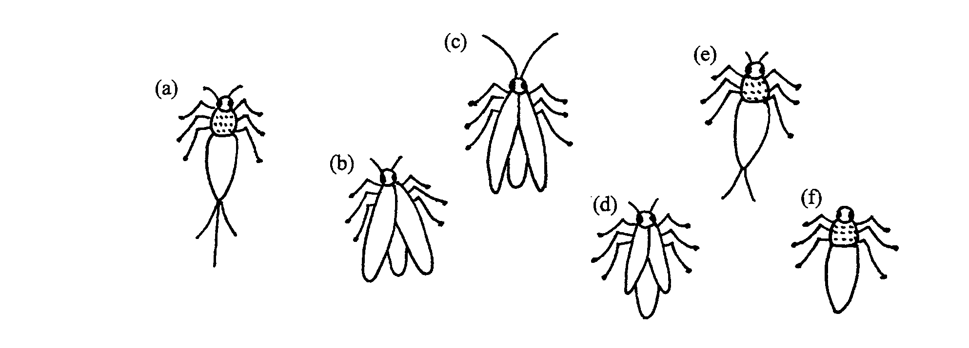
Section B Short Answer (25 marks)

21 Biologists usually use the five kingdom classification system when grouping organisms. Name the five kingdoms and give one example of an organism for each kingdom. (5 marks)

22 A key has been devised to classify the above group of insects.

la Animals with wings go to 2
lb Animals without wings go to 4

2a Wings shorter than abdomen specimen D
2b Wings not shorter than abdomen go to 3

3a Antennae lcm or more in length specimen C
3b Antennae less than lcm in length specimen B

4a Filaments extending from abdomen go to 5
4b No filaments extending from abdomen
specimen F

5a More than two filaments on abdomen specimen A
5b Two or less filaments on abdomen specimen E

Use the devised key to identify the two organisms shown below.
Both of these organisms were collected during a biological survey on an island off the coast of Western Australia.
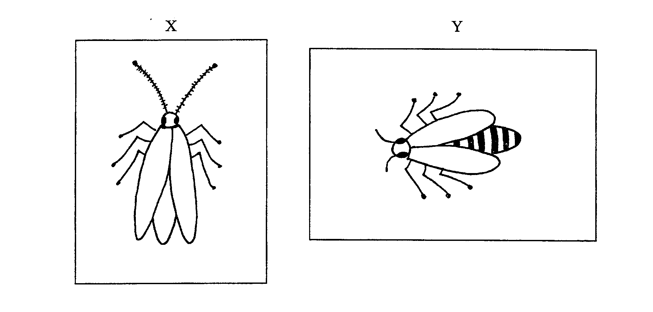

X ____________________________________

Y ____________________________________

(2 marks)

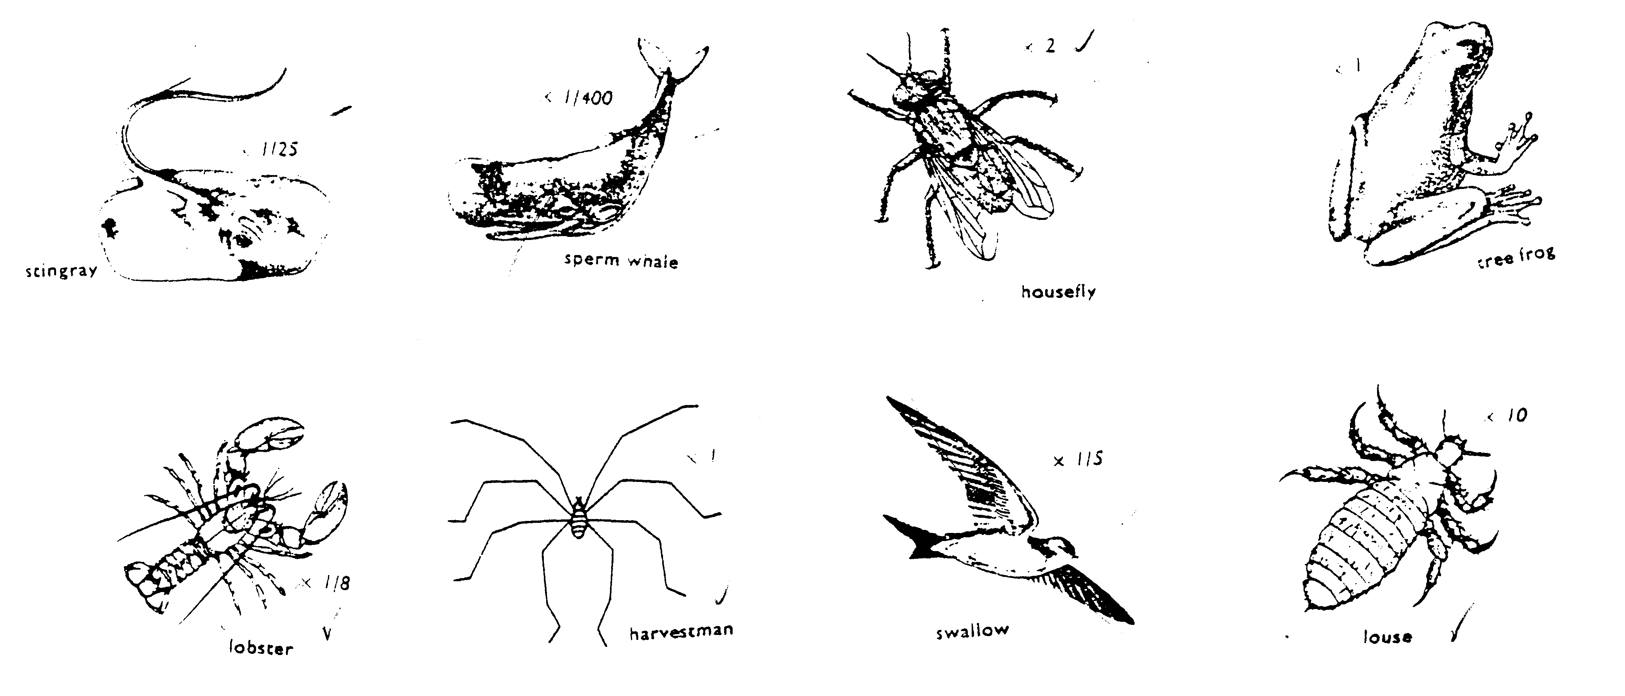
23 Devise and write out in standard form a dichotomous key for the following organisms:

(4 marks)

24a The following passage describes observations made in a desert area of Australia. ‘Most sand desert animals are nocturnal and come out during moonlight hours to hunt and search for food. The vegetation consists of spinifex clumps, tufts of cane grass and mulga. Beetles search for succulent leafy parts of these plants. The beetle fall prey to wolf spiders, geckos and assassin bugs. Marsupial mice are found in burrows. These animals eat insects and geckos. The mice and geckos are eaten by the sand goanna.’

From this information, construct a food web diagram showing the relationships between the organisms mentioned. (6 marks)

b Name the following

  - First order consumer
  - Third order consumer
(2 marks)

c An insecticide is used to kill a locust plague unfortunately it also kills the bettles. Discuss what affect if any it will have desert food web?
(2 marks)

d Explain in terms of energy why it would be unlikely a food web would contain six trophic levels.
(4 marks)

